**Dungeon 1|Enemies**

**Dungeon 1|Enemy Standards:**

**Colors:** Oranges, browns and yellows to fit the theme of the dungeon.

**Shadows:** Under each enemy is a shadow that communicates difficulty

**Weapons:** They don’t reload. Most enemies won't just spam damage out though, they will have basic pausing when they fire. Ex. Fire three bullets then a small pause. (Bursts)

**Drops:** Drop weapons based on their status as an enemy. (Size and strength) Weak weapons

**Movement:** Don’t pause to attack unless specified. Turn speed is same as the main characters unless specified.

**Distance:** Runs on a basic three circle system. Long, medium and short.



Long: These enemies want to stay at a long range from the player, and don't like close range encounters.

Medium: These enemies want to stay a small distance away from the player.

Short: These enemies want to get all up in the player’s business and f*ck them up.

**Dungeon 1|Enemy Types:**

**Enemy 1:** Small alien

**Type:** Weak

**Distance:** Medium

**Health:** 40

**Damage:** 10 per bullet (3 bullets per attack sequence)

**Aesthetic:** Similar to grunts from Halo. Small weapons,weak looking with a generous hitbox. Have a sash on their backs.

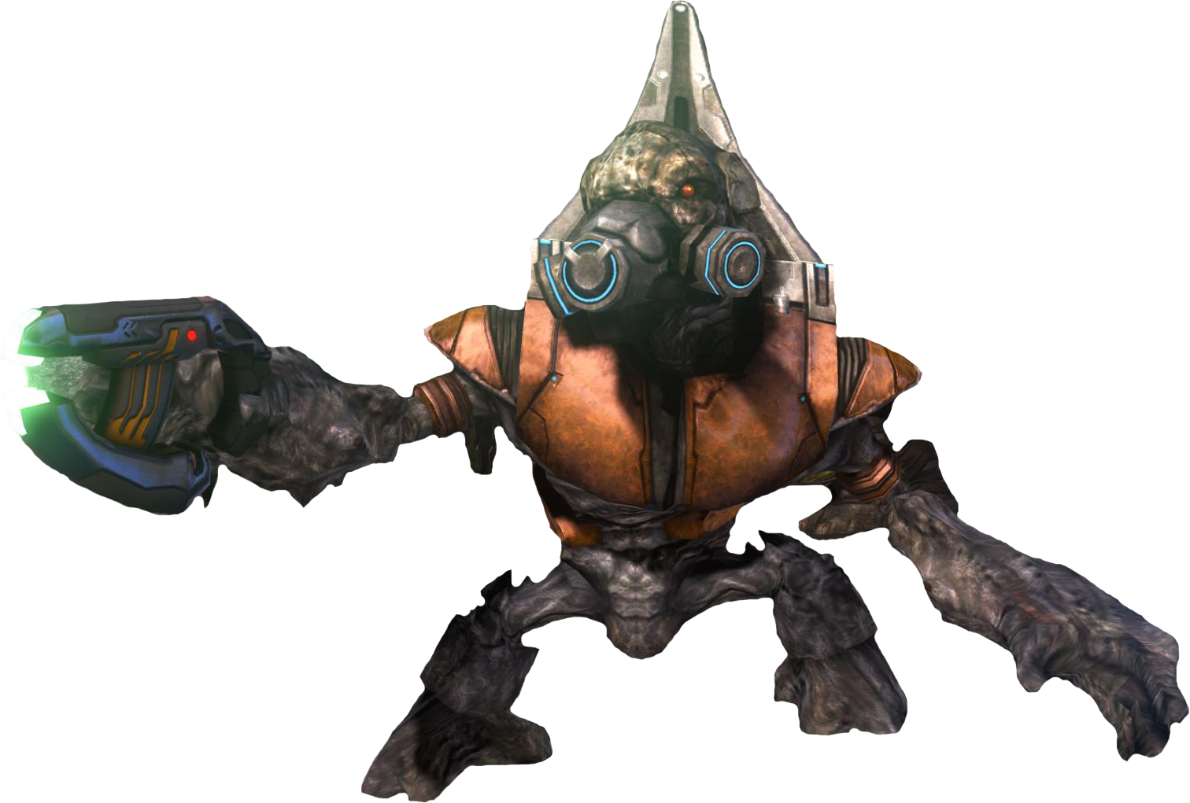

(*Insert actual art here*)

**How the enemy will attack:** They have a small pistol that fires at a semi-automatic rate. The projectiles they fire will be on the faster side but do weak damage to offset their quick speed. They don’t have a melee.

**Audio:** Small laser sound.

**How they will move:** They move slow, waddling around. By waddling i mean that they sway from side to side a bit when they walk. They back up from the player when he gets closer to them. Move slower then the player.

**Audio:** small, light footstep sounds.

**Range of attacks:** Their weapons don’t have damage fall off, they can hit the player for full damage from any range. When the bullets hit the walls, they go away.See distance for more info.

**Strengths:** No real obvious strengths, depending on level design, numbers might be a strength of them.

**Weaknesses:** Don't have the ability to burst down the hero's health. Don't deal enough damage to actually hurts the player substantially. They are just weak. Very basic.

**Abilities(If Any/Optional):** Later on, there may be more versions of them. Like a kamikaze version, when they die they explode, so on and so forth. As of right now, the basic Dungeon 1 versions have no abilities.

**Death:** When they die, by regular bullets, they fall over in the opposite direction that they were shot from. Have a very small chance to drop a weapon.

**Audio:** an obnoxious death sound, either loud and drawn out or funny, like a funny “AHHHHHHHhhhh…..”

**Why is this enemy fun to fight?**

These would be more of the comedy enemies. Because they’re easy to kill, the fun won't be the challenge of them, but more of how they die or act. **Maybe in the level design, they could be more hoard-like, so the fun would be mowing them down.** *(Leaning more towards the horde.)*

**Enemy 1:** Strong Alien

**Type:** Medium strength

**Distance:** Long/Short

**Health:**

* Swords: 200
* Rifle: 150

**Damage:**

* Swords: 75 per swipe
* Rifle: 20 per bullet (5 bullets per attack sequence)

**Aesthetic:** Similar to the Captains or Vandals from Destiny. Tall and lanky with a cape. Decently balanced hitbox to their size.

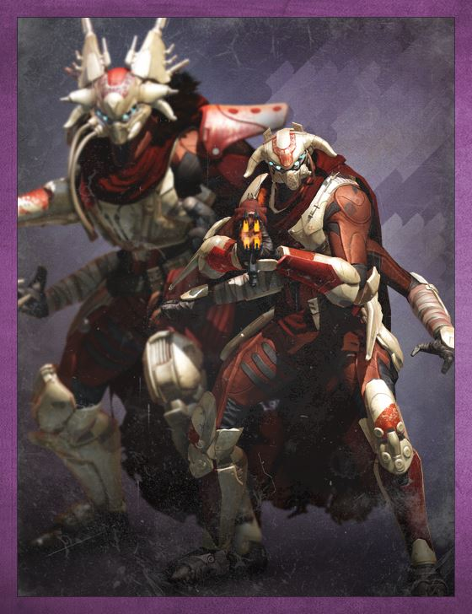

(*Insert actual art here*)

**How the enemy will attack:** There will be two distinct versions of the enemy. One that wields a sword and one that uses an Rifle.

Sword: The sword version will attack will fast paced sword swings, going from the right to left, then back.

**Audio:** a slice sound that ends in a high pitch.

Rifle: fire a long burst of average speed projectiles that if all connect on the player will deal a moderate amount of damage. They get flustered if the player is close to them and won't attack as often or focus more on running away.

**Audio:** a strong bullet sound that repeats over the burst.

**How they will move:** Each version will have a distinct movement style. Speed is at the same as the player. Swords can move a little faster, encourages “Kill them now”

Sword: Will be highly aggressive, moving quickly towards the player in a straight line, moving to swipe at the player. They will sway from side to side a bit as they move. *(Optional: Once they get within close enough range to the player, they will do a small dash slice attack, moving forward at a quicker rate and attacking at the same time.)*

**Audio:** A light stepping noise as they walk.

Rifle: Hang back and pop shots from a distance, either putting some other enemies in front to take the brunt of the damage and/or jumping behind cover when taking too much damage.

**Audio:** A light stepping noise as they walk. A grunt when the jump behind cover.

**Range of attacks:** Swords by nature have to be right next to the thing they want to attack, so close range for that. As for the Rifle, they can be primarily longer range. See distance for more info.

**Strengths:** They two forms combo well together, allowing for great synergy between mixed groups.

**Weaknesses:** They both have their distinct weaknesses. The sword versions are significantly vulnerable if the player can keep them at long range. While the Rifle versions can be take out very easily by getting close to them and dealing burst damage.

**Abilities(If Any/Optional):** Swords may have a small dash attack once in range, to close the distance. While the Rifle versions may have a dash attack for avoiding damage from a range.

**Death:** When they die, by regular bullets, they fall over in the opposite direction that they were shot from. Have a small chance to drop a weapon.

**Audio:** Deeper more gurgling death sound.

**Why is this enemy fun to fight?**

Because of the two forms, they take more strategy to fight and reward smart play. Just shooting randomly at the rifle version won’t work if they can out damage you from afar, and if you can out damage them, then the swords are going to be a problem for as they are going to distract you from the longer ranges of the Rifle. All in all, they reward careful play.

**Enemy 1:** Brute/Heavy Alien/Golems

**Type:** High strength

**Distance:** Short with a long ranged ability

**Health:** 750

**Damage:** See “How the enemy will attack”

**Aesthetic:** Large with massive arms and a stone body.

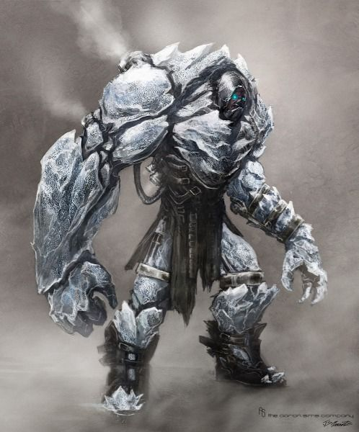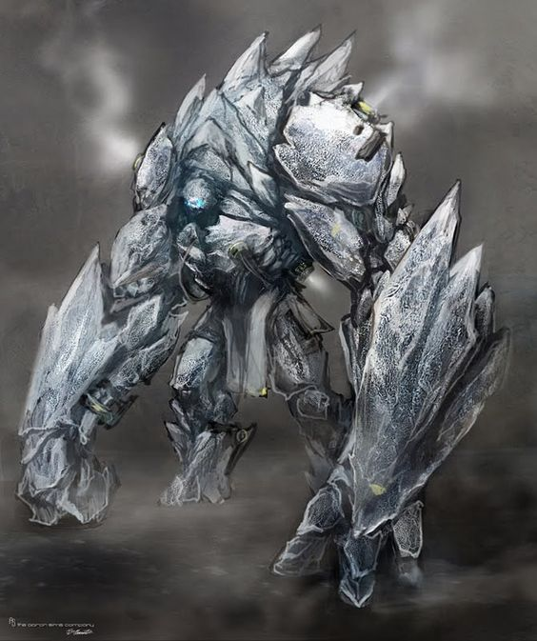

(this is ice but you get the idea)

(*Insert actual art here*)

**How the enemy will attack:**

* The swing there large arms for a heavy melee that hits the player. **Deals 100 damage**
* They can also slam the ground with knocks the player back, dealing damage(*Optional: More damage if they hit a wall*). **Deals 50 damage**
* There last attack is a boulder throw. A medium speed projectile that does A LOT of damage. **Deals 150 damage**

**Audio:** Big heavy sounds with a lot of umph. Earthy tones.

**How they will move:** Slow but with a lot of weight. They walk on two legs but are hunched over. (Like above). Pause to attack, and wind up a lot for the slam. Turn speed is slow.

**Audio:** Heavy sounds.

**Range of attacks:** Short range except if they are at long range, they can throw a boulder.

**Strengths:** Heavy damage output and a lot of health.

**Weaknesses:** Very slow. Can’t turn fast and have long windup to their attacks.

**Abilities(If Any/Optional):** Their boulder throws and slams are there two more unique abilities. Explained above.

**Death:** When they die, by regular bullets, they fall forward(in the direction they were facing) and smash into the ground, hard. Drop a decent item and maybe a good item.

**Audio:** Low deep moan.

**Why is this enemy fun to fight?**

They are extremely dangerous and hard to kill, requiring a good foresight to avoid their attacks and a strategy as they are rarely fully alone. They must be kept at a distance, as they do a lot of close range damage, but there boulder throws can easily kill you. They are satisfying to fight because they are challenging.